Using IoT to simulate a parking bay and provide real time updates via an app based on external factors

Student: Tarikh Chouhan

Supervisor: Dimitris Dracopolous

Institute: University of Westminster

# Introduction

(Talk about the rise of cars and AI, how it’ll impact road and road users, congestion etc.

Get rid of sub headings below?

)

This section of the report will cover the general scope of the project and what problem the project aims to tackle.

As car manufacturers continuously unveil new cars to the public every year and as the world’s population continues to grow, a trend can be seen with these two factors. There are more cars appearing on the road every year due to growing population[1]. This trend can have negative repercussions in terms of environmental and financial factors (e.g. more money being spent on petrol, insurance claims increasing, pollution, hazardous chemicals entering the atmosphere). However there are positive effects to this trend such as new technology emerging through innovative solutions and moving towards a society revolving around self-driving cars.[2] Due to the trend outlined, finding parking bays to park in will be a challenge as more cars will be on the road hence this project proposes a solution to combat this problem.

This project will be comprised of chapters and segments and each chapter will individually contain highly detailed information in order to fully understand this report. The report will go through an overview of a mathematical concept which is seen every day in our lives and has only became popular in the last 100 years; queueing theory. Furthermore, it will delve a bit into traffic engineering and seeing what’s already in place at the moment. As well that, this report will contain feedback and information I have gathered from companies revolving around transport engineering. This report will also delve into an interesting and highly sophisticated part of computer science; machine learning, as this report will outline an overview of what is essentially machine learning and AI as well as discussing the model I have chosen to use in my solution. Moving onto the technical aspect, this report will show the tech stack behind the proposed solution as well as explaining the choice for the chosen technologies. Diving deeper, it will show the source code behind the solution and explain concepts that might not be familiar with university students with such as dependency injection, the maven build life cycle as well as using GIT for source control.

## Current and future problems of not finding parking bays efficiently – LR?

As more cars will be on the road, available parking bays will be less frequent which in turn would frustrate drivers as they look for an available bay. As a result of this frustration, drivers tend to park illegally and end up having to pay a penalty/fine. Local councils are generating massive amounts of revenue by handing out parking fines. The following statistics paint a picture on how significant the car parking industry is:

|  |  |  |  |  |  |
| --- | --- | --- | --- | --- | --- |
| Surplus in £(millions) made in parking fines per local council [3] | | | | | |
| Local authority | **2010/11** | **2011/12** | **2012/13** | **2013/14** | **2014/15** |
| Westminster | 38.2 | 41.6 | 39.7 | 51 | 46.4 |
| Kensington & Chelsea | 21.1 | 28.1 | 30.4 | 33.5 | 33 |
| Camden | 21.1 | 25 | 23.5 | 24.9 | 24.5 |
| Hammersmith & Fulham | 16.6 | 19.5 | 19.4 | 23 | 23.8 |
| Wandsworth | 14.4 | 16.1 | 15.9 | 19.7 | 20.4 |
| Brighton & Hove UA | 12.7 | 14.4 | 16.3 | 18.1 | 18.6 |
| Haringey | 3.3 | 5.3 | 5.2 | 5.7 | 16.1 |
| Islington | 5.6 | 10.9 | 8.2 | 10.4 | 13.7 |
| Nottingham City UA | 3.7 | 3.3 | 11.8 | 12.1 | 13.3 |
| Hackney | 4.7 | 5.9 | 7.8 | 8.2 | 10.8 |
| Brent | 3.9 | 2.7 | 2.7 | 8.3 | 10.5 |
| Tower Hamlets | 6 | 5.8 | 7 | 8.3 | 10 |
| Birmingham | 5.1 | 5.5 | 6.9 | 7.8 | 9.7 |
| Lambeth | 7 | 5.8 | 12 | 7.2 | 9.7 |
| Milton Keynes UA | 6 | 6.6 | 6.7 | 8.2 | 9 |
| Cornwall UA | 8.2 | 7.9 | 8.1 | 8 | 8.7 |
| Manchester | 1.9 | 6.3 | 8.8 | 8 | 7.9 |
| Hounslow | 6 | 7.3 | 6.4 | 7.8 | 7.7 |
| Newham | 3.9 | 7.3 | 8.2 | 7.2 | 7.3 |
| Merton | 4.4 | 5.7 | 6.9 | 7 | 7.2 |

Furthermore, unable to find available parking bays could have negative repercussions on a global scale such as the increase of greenhouse gas since harmful emissions would be emitted from the car as it spends more time and fuel to look for a parking bay having the driver arrive at its destination. As well as that, driving around to look for a parking bay will use up fuel hence the driver would need to spend money to fill their cars more frequently compared to finding a parking bay that is readily available.

## Current solutions to the problem

# Literature Review

There have been multiple documents produced and published regarding the issue around car parks; whether it is the mathematics behind it or a simulating the construction of a parking lot. As well as that there are documents providing in depth articles from well-known established bodies such as the RAC foundation. These documents can vary from articles and publications to thesis’s. In this section of the report, you will be updated and be equipped with the latest works currently being undertaken in the parking community within traffic engineering as well as getting a brief overview of the mathematics behind it.

Queuing Theory –

Queues are everywhere. They can be observed in the most obvious places such as customers lining up to pay for their goods in a shop, patients being on a waiting list to see the GP or drivers waiting their turn to fill up their car in a petrol station. Queues can also be found in places where the average person wouldn’t typically realise they’d find a queue as instructions being executed on a CPU or sending and receiving packets of data to browse the internet. Queuing theory was first written by Danish mathematician, Agner Krarup Erlang, back in 1909. Agner worked at a telephone exchange which consisted of using jack plugs and plugging them into a circuit to route phone calls. Agner wanted to know how many circuits was needed to provide a sufficient service to a local village and thus began researching and then published his findings in the paper ‘The Theory of Probabilities and Telephone Conversations’[4].

Queueing theory in its simplest form, deals with problems involved with queues or waiting. Most problems regarding this concept have 2 entities in common; ‘queue’ and an ‘activity’. ‘Queue’ is the current wait and ‘activity’ is the server. So a practical situation would be a queue that represented a queue of customers and activity would represent a staff member at the cash till. The staff member deals with the customers one by one effectively taking care of the queue.

There are some characteristics to these entities that are present in every queuing problem. The activity would need to determine on what the queue discipline would be i.e. FIFO (first in first out), LIFO (last in first out) etc. Another concept present in queuing problems is understanding what type of queue are we dealing with. Baulking; where customers decide not to join the queue if it’s too long, reneging; where customers leave the queue if they have waited for too long to be served or jockeying; customers switch between queues if it’ll help them get served quicker. Furthermore, another important variable to consider when dealing with queuing theory is understanding the behaviour of the arrival process. This means understanding how customers would join the queue; e.g. in fixed timed intervals or variable times, would they join it as a group or as a single entity.

‘Applicability of information technologies in parking area capacity optimization’ written by Maršanić Robert and Pupavac Drago is a research paper how to efficiently design parking areas based on waiting-line models; also known as queuing theory[5]. In their paper, they were trying to find an efficient model to use for their car park, ‘Delta’ located in a city in Croatia. They compared their findings with different models of car parks i.e. a car park with a single-channel queueing model and a multichannel queueing model and found out that having a single-channel queueing model is not as efficient as having a multichannel queueing model as the single-channel service deteriorates in peak hours as it cannot cater for all the vehicles arriving during peak hours.

Furthermore, the research paper from Shuguo Yang and Xiaoyan Yang titled ‘The Application of the Queuing Theory in the Traffic Flow of Intersection’ delves into the concept of using queueing theory to analyse traffic conditions on an intersection[6] which is similar to analysing car parks as it revolves around the same concept. This paper uses first hand data as they acquire their data from the intersection. This can be seen on Table 1 on their paper[7]. By collecting first hand data, the results generated from this paper would be reliable only in the location that they acquired their results from. They use the data to find the average number of cars arriving to the intersection. This paper then goes onto give the reader a clear and concise conclusion by comparing their results from different scenarios i.e. comparing the overall probability that there will be zero cars left in the queue in an intersection with two, three and four lanes. It further enforces the fact that using queuing theory is a sound and practical approach when dealing with vehicles and roads as this model can give a huge insight onto vehicles waiting on the road.

Machine Learning –

With technology rapidly increasing and most of the technology we use are becoming automated, the rise of Artificial Intelligence (AI) is becoming more and more dominant. AI in essence involves machines that behave, e.g. think, like humans[8]. There is then a multitude of categories that fall under AI and ‘Machine Learning’ is one of them. Machine learning is all primarily about detecting patterns in data and identifying future patterns based on historic patterns to make a solid prediction. A common example is the autocorrect feature in Google. If you misspell something on Google, Google will suggest the correct word.

Machine learning is on the rise when it is used in conjunction with vehicles. More and more vehicles are incorporating AI into them. An example of this is the Tesla’s autopilot feature. And as the world progresses further, the further we progress up the autonomous levels. We are moving towards a Level 3 autonomous society. Level 3 autonomousity revolves around the car actively scanning and monitoring the environment by using external sensors such as LiDAR, infrared sensors, ultrasonic sensors etc. And quite recently, a vehicle that aims to provide complete level 4 autonomousity was showcased in CES 2018[9]. As you can see, machine learning and vehicles does go hand in hand.

There are many algorithms to use when it comes to incorporating machine learning. An important factor in choosing what algorithm to use depends on the data you are dealing with. In this report, logistic regression will be used as it is the most sound and practical approach with the data that we will be dealing with. The reason for this is because logistic regression is typically used when the dependent variables are binary. Logistic regression is used to predict one outcome out of a possible two outcomes. For example, given a scenario where a patient who was being tested for asthma, the only outcomes would either be ‘yes’ or ‘no’. Likewise, in the context of parking bays, the parking bay is either occupied or vacant. There can be no inbetween. For this reason alone, logistic regression the ideal algorithm to use.

The logistic regression is modelled with the following equation:

$p=\frac{1}{1+e^{-(b_{0}+ b_{1}x)}}$

Logistic regression uses maximum likelihood estimation (MLE) to obtain the coefficients in the above equation. This can be thought of as fine tuning the model so that the model will be able to give us a clear and more accurate model to use.

## Aim and Objectives:

The aim of this project is to help solve an on-going problem most car drivers face daily; finding an available bay to park in. This project will aid and help car drivers find a car parking bay that they’ll be able to park in without driving further than necessary.

The objectives of the project are:

1. Creating the sensor :

This will be achieved by creating a sensor (using an Arduino Uno) that will record the data from an ultrasonic sensor, GPS module and a thermistor module as well as an integrated Wi-Fi module.

1. Code the sensor to detect a change in the environment :

Once the modules acknowledge a drastic change in the environment, the results will be shown to the user via an app hence indicating whether or not the bay is vacant or occupied based on the change in environment.

1. Incorporate machine learning :

As well as that, the app will learn how the data correlates to the bay being vacant or occupied, essentially machine learning. This will be achieved by implementing the concept of neural network as well as using the logistic regression algorithm. The reason for using the logistic regression algorithm is because it is used to answer questions that has binary answers (i.e. two possible answers) and this fits my situation as there are only 2 answers in my context; the parking bay is either occupied or vacant. By implementing this feature, the app will be able to predict whether or not the bay is being used and will come in handy if for some reason the sensor cannot fulfil its purpose (e.g. if there are networking issues, wiring issues, external factors such as rain etc.).

1. Create the server and the database :

The server will be used to send the data to and from; the app and the sensor, over the HTTP/HTTPS protocol. The database will be used to store the sensor’s information it gathers.

1. Design of the sensor :

Designing how the sensor should look aesthetically in order to make the sensor more efficient in terms of accurately reading the changes in environment.

1. Developing the app :

The app will be developed for the android platform. As well as that, it will be developed using the Agile methodology. The app will fetch data from the server and populate a map which will show parking bays that are vacant / occupied near the user. Furthermore, the app will need to be user friendly and not have too much elements for the user to interact with as this app will typically be used whilst the user is behind the wheel of a car so every effort will be made to ensure the user focuses on the road and not on the app as this could pose a danger to the driver. The app will be laid out in such a way that the user should know enough information by interacting with the app by no more than 5 seconds.

# Requirements

How you got these requirements e.g. prototyping, looking at other devices like it

To gather the requirements for this project, I have used a range of requirement gathering techniques such as creating a prototype to see any improvements or to see any missing requirements. By doing this I’ll be able to see if my prototype is practical. Furthermore, I compared different devices/apps already out there in the public, that tries to combat the problem stated. By comparing and contrasting different devices to each other, I will be able to gain a huge insight on the common requirements they fulfil as well as seeing any potential requirements they may have missed out thus making my prototype unique.

Firstly, I have looked at alternative solutions proposed by different companies to combat the problem stated. One of the IT giants; Google, is already making progress in terms finding a solution to this problem. They have implemented a solution and it is available on Google Maps. Their solution works using historic data with machine learning to predict the availability of car parking bays[10]. Whilst this is a step in the right direction to solving the problem described, it is not as accurate as having a physical sensor embedded to the parking bays. As the world progresses further in technology, more and more devices are being connected to the internet, the concept of IoT (internet of things) will be greatly beneficial here and will outperform the use of machine learning.

Another solution proposed by the start-up company, AppyParking, is also aiming to tackle the problem. AppyParking uses a sensor that is embedded onto the road and provides real time updates to the user via their app. Their solution is currently implemented in Westminster and Coventry. Their sensors has immensely helped with the problem outlined as it has helped Coventry City Council recognise an approximate £475000 lost revenue due to parking bays that were not either used or placed efficiently[11] whilst providing users real time updates to the available parking bays which in turn has led to 30% fewer miles driven looking for bays and 22% reduction in parking congestion during peak hours[12]. Whilst this is similar to my proposed solution, it lacks the use of machine learning which would be greatly beneficial because in the unfortunate event that the sensor stops working, the app would not be able to notify the user if the bay is vacant or occupied.

Moreover, another company that is closely related to this field is Inrix. They work closely with companies such as BMW and Audi. Inrix also gathers data regarding car parks and congestion on the roads in order to provide a huge collection of data in order to understand the current trend and patterns of road usage as well as making the roads more efficient. One idea that they have proposed to combat the problem statement is to use ultrasonic sensors[13]. Their method revolves around fitting cars with ultrasonic sensors as opposed to more evasive methods such as physically implanting sensors on the road. This has its pros and cons. It is more economically viable to implant sensors on cars rather than on roads as that would mean less cost since there would be no need to refurbish the roads to incorporate sensors. But a drawback would be the amount of data that would be gathered about the driver and how Inrix would store, or even share, the data.

Comparing the above innovations proposed by these companies, I can see each of them does have its strength and weaknesses therefore I will aim to build my prototype to include the main logical purposes the above serve and also; to include what some of them have missed, i.e. machine learning. I will be using an Arduino Uno to build the prototype and also be using a wifi module for wireless communication as well as wiring up a thermistor and an ultrasonic sensor.

Furthermore, I will need to cater requirements for the UI of the android app that I will be developing. Below are the images of the AppyParking app for Android. My initial reaction at first glance was that there was too much information on one screen. It should’ve been spaced out more and having all the tabs and icons centralised at the bottom of the screen was not efficient. Upon using it, it was pretty confusing to navigate through the app because the tabs on the icon did not represent what the tab would do/perform. Even more, the app became unresponsive as I navigated through the map. This might be due to the fact that it tries to display all the map data at once hence sending multitudes of http requests and receiving responses in a short amount of time whilst the phone is busy constantly busy updating the UI.

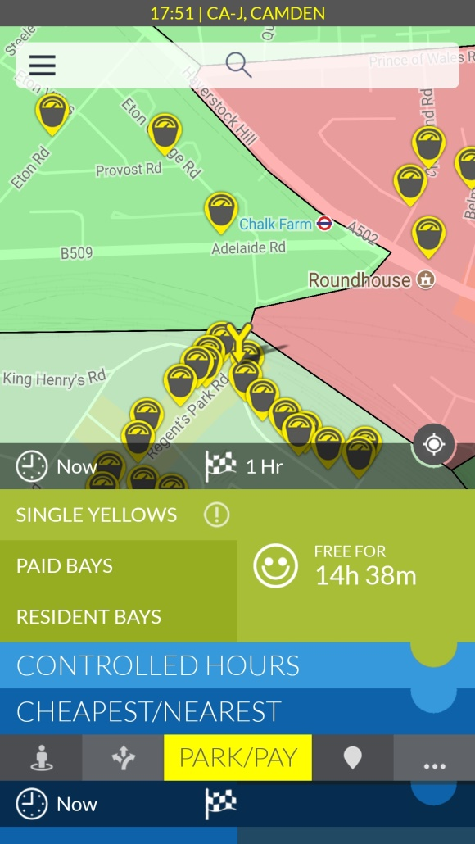 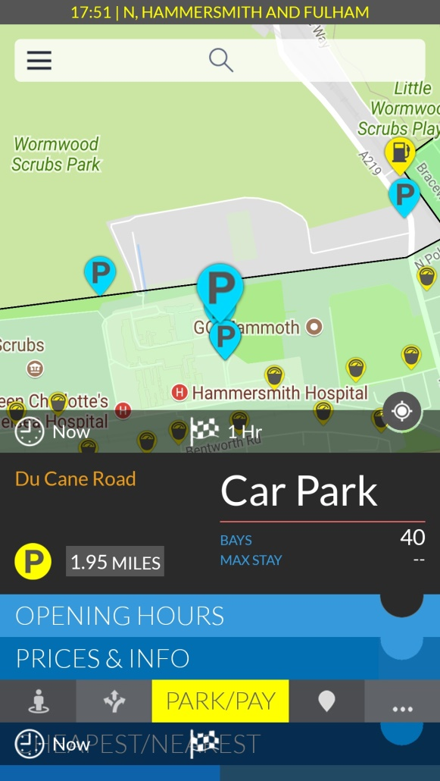

Figure 1 (left). Figure 2 (right).

As a result of this, I will be developing the app with a simplistic UI. One has to keep in mind that this app will mostly be used when a driver needs to find a parking bay hence the UI will not have many navigation tabs in the front page and it will need to give a clear and concise outcome within 10 seconds as the driver cannot have their attention diverted from the wheel as it is a potential risk to their lives.

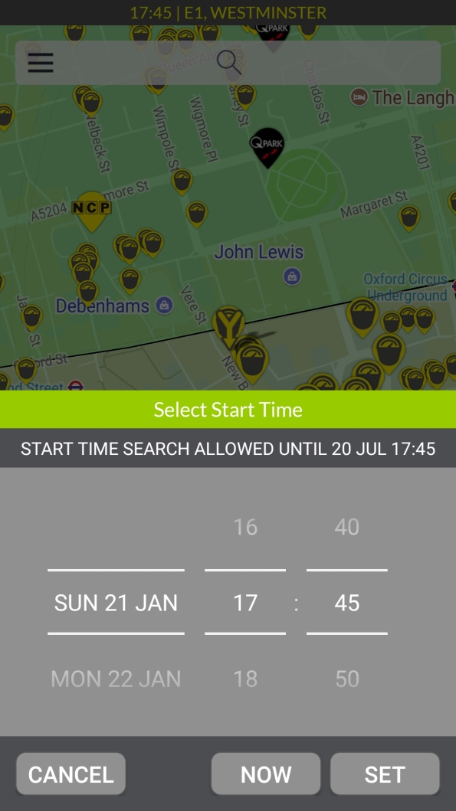 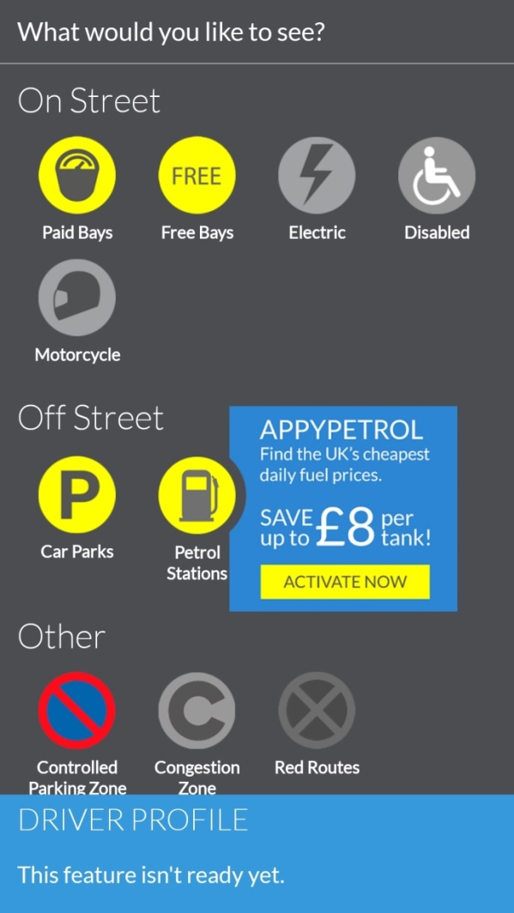

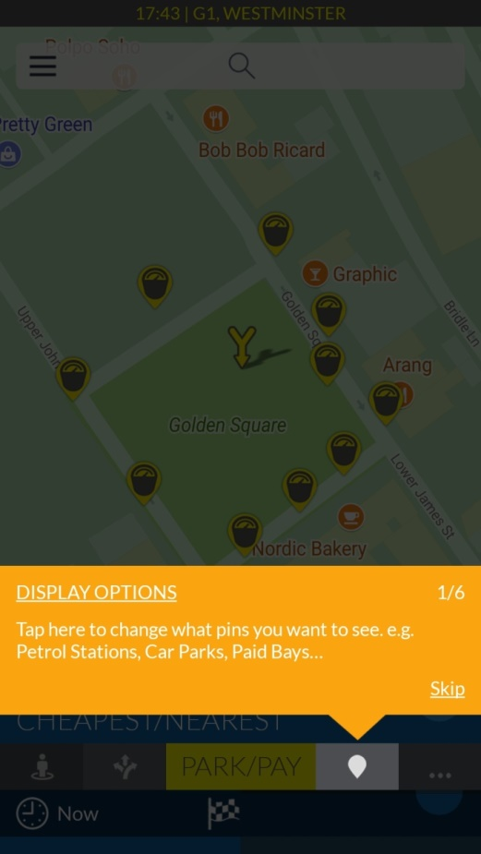

# Design

This section of the report will cover all the design aspect for the project. It will include action diagrams, sequence diagrams, use case diagrams as well as storyboards. Furthermore, it will show the project in an architectural manner in terms of the structure and how the app is built by UML diagrams.

Sequence diagrams –

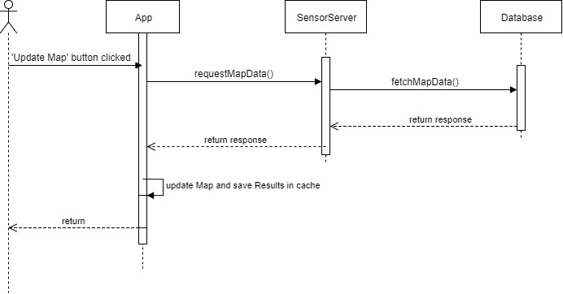

Figure (1) – Above – Shows the interaction with user and app

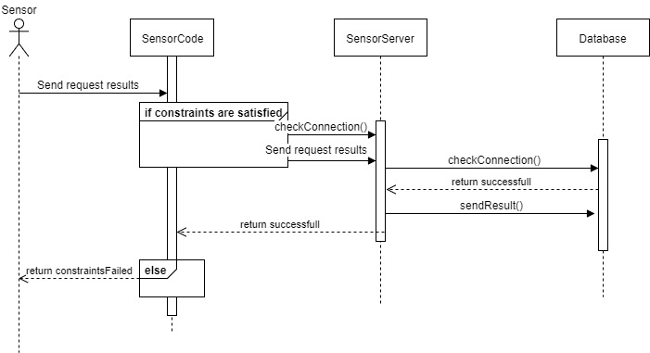

Figure (2) – Above – Shows the sensor interaction with the server and database

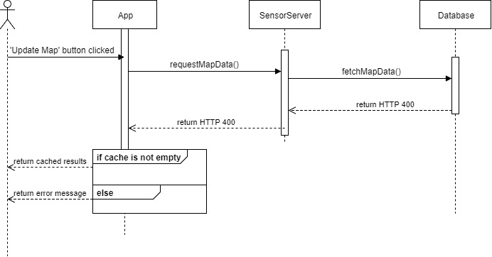

Figure (3) – Above – Shows the interaction of the user if server cannot connect to database

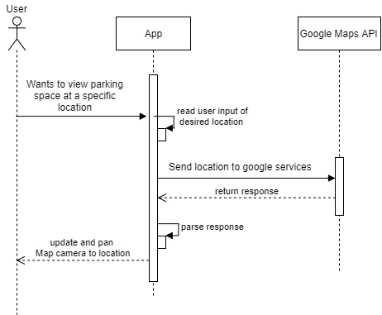

Figure (4) – Above – Shows the interaction of the user when the user wants to check for a parking spot in a certain area.

Action Diagrams –

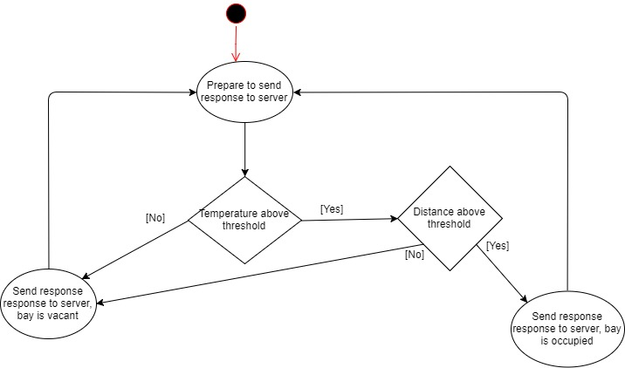

Figure(1) – Above – Shows the activity diagram of the sensor

Figure (2) – Below – Shows the activity diagram of the user interacting with the aoo.

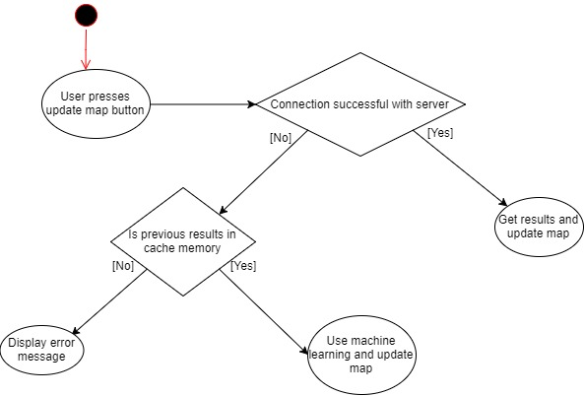

Use Case Diagrams –

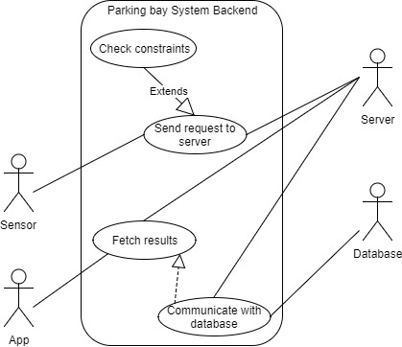

Figure (1) – Above – Shows the uses cases of the backend of the system

Figure(2) – Below – Shows the use cases of the user requesting to a new location to look for a parking bay

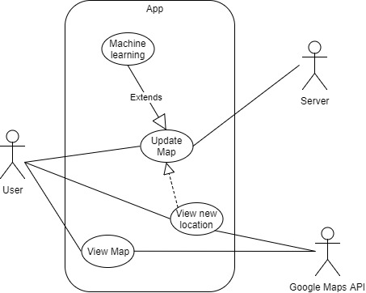

# Methodologies

Tech Stack,

Diagrams (UML, Sequence, Action)

1. http://www.bbc.co.uk/news/uk-england-35312562
2. https://www.forbes.com/sites/oliviergarret/2017/03/03/10-million-self-driving-cars-will-hit-the-road-by-2020-heres-how-to-profit/#3c617ee37e50
3. RAC Foundation, December 2015, Council parking 'profits' up again in England, Available at: http://www.racfoundation.org/media-centre/council-parking-profits-up-again-in-england-2014-15
4. http://runeberg.org/matetids/1920b/0030.html
5. PDF paper
6. Again pdf
7. Again pdff
8. https://www.exastax.com/machine-learning/the-difference-between-ai-machine-learning/
9. http://www.bbc.co.uk/news/technology-42599345
10. Google Blogs, August 2017, Put it in park with new features in Google Maps, Available at:https://www.blog.google/products/maps/put-it-park-new-features-google-maps/

   
11. http://www.appyparking.com/rta.html
12. http://www.appyparking.com/rta.html
13. http://inrix.com/blog/2017/12/ultrasonic-sensor-parking-availability-technology/